Unit 1 My Favorite Time of Day

A
2. I take a shower while my mom makes breakfast.
3. I listen to music while I walk home from school.
4. I think about my day while I get ready for bed.

B
2. I watch the basketball players shoot the ball.
3. I hear the children shout at one another.
4. I watch the rabbits hop in the gardens.

C
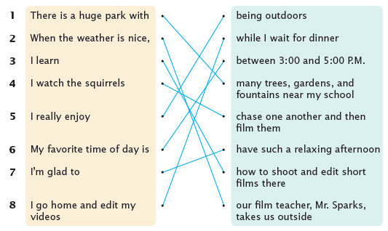
1. There is a huge park with many trees, gardens, and fountains near my school.
2. When the weather is nice, our film teacher, Mr. Sparks, takes us outside.
3. I learn how to shoot and edit short films there.
4. I watch the squirrels chase one another and then film them.
5. I really enjoy being outdoors.
6. My favorite time of day is between 3:00 and 5:00 P.M.
7. I’m glad to have such a relaxing afternoon.
8. I go home and edit my videos while I wait for dinner.

Unit 2 The Worst Day of My Life

A
2. My soccer team was losing the match.
3. My friends were having gross sushi for lunch.
4. I was waiting for my friend for an hour.

B
2. I felt so upset that I wanted to cry.
3. I felt so annoyed that I wanted to run away.
4. I felt so frustrated that I wanted to scream.

C
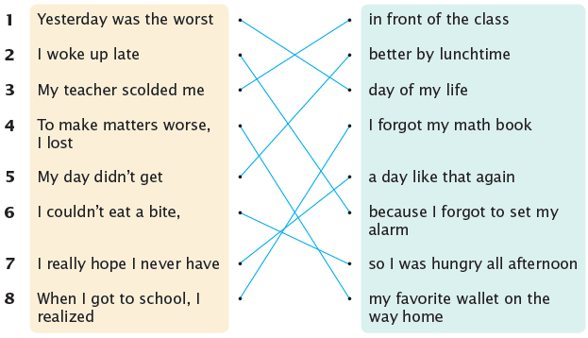

1. Yesterday was the worst day of my life.
2. I woke up late because I forgot to set my alarm.
3. My teacher scolded me in front of the class.
4. To make matters worse, I lost my favorite wallet on the way home.
5. My day didn’t get better by lunchtime.
6. I couldn’t eat a bite, so I was hungry all afternoon.
7. I really hope I never have a day like that again.
8. When I got to school, I realized I forgot my math book.

Unit 3 School Lunches Around the World

A
1. In Ukraine, students eat big lunches to stay full.
2. In South Korea, students eat healthy foods to stay strong.
3. In Colombia, students eat nutritious foods to stay healthy.
4. In the U.S., students eat delicious foods to stay full all afternoon.

B
2. They might have fish, fried chicken, or pork that is covered in sauce.
3. They might have meatballs, chicken, or plantains that are fried in oil.
4. They might have carrots, peas, broccoli, or beans that are cooked in sauce.

C
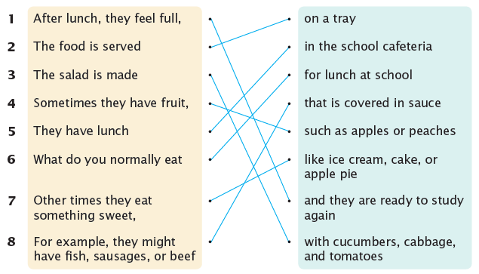

1. After lunch, they feel full, and they are ready to study again!
2. The food is served on a tray.
3. The salad is made with cucumbers, cabbage, and tomatoes.
4. Sometimes they have fruit, such as apples or peaches.
5. They have lunch in the school cafeteria.
6. What do you normally eat for lunch at school?
7. Other times they eat something sweet, like ice cream, cake, or apple pie.
8. For example, they might have fish, sausages, or beef that is covered in sauce.

Unit 4 The Most Popular Pets

A
2. They said rabbits are the cutest and most interesting pets.
3. They said fish are the cheapest and prettiest pets.
4. They said cats are the smartest and fastest pets.

B
2. Eleven students like hamsters the best because they are easy to feed.
3. Seven students like dogs the best because they are easy to teach.
4. Ten students like iguanas the best because their cages are easy to clean.

C
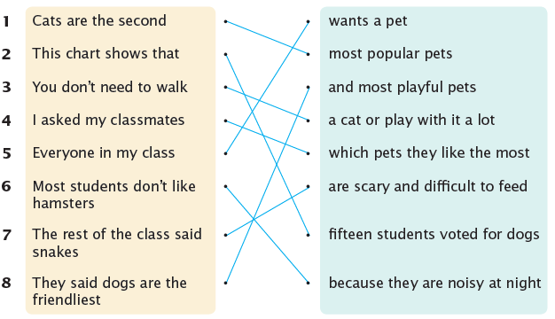

1. Cats are the second most popular pets.
2. This chart shows that fifteen students voted for dogs.
3. You don’t need to walk a cat or play with it a lot.
4. I asked my classmates which pets they like the most.
5. Everyone in my class wants a pet.
6. Most students don’t like hamsters because they are noisy at night.
7. The rest of the class said snakes are scary and difficult to feed.
8. They said dogs are the friendliest and most playful pets.

Unit 5 The Best Place to Travel

A
2. I suggest you try the fresh lobster.
3. I suggest you take part in the sand sculpture contest.
4. I suggest you photograph the rock formations.

B
2. I have been there twice with my family.
3. I have been there a few times with my aunt.
4. I have visited the museum four times with my brother.

C
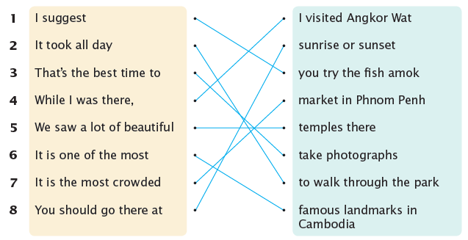

1. I suggest you try the fish amok.
2. It took all day to walk through the park.
3. That’s the best time to take photographs.
4. While I was there, I visited Angkor Wat.
5. We saw a lot of beautiful temples there.
6. It is one of the most famous landmarks in Cambodia.
7. It is the most crowded market in Phnom Penh.
8. You should go there at sunrise or sunset.
Unit 6 Save the Environment

A
2. You should reduce the amount of food you waste.
3. You should reduce the amount of air pollution you make.
4. You should reduce the amount of plastic you throw away.

B
2. Remember to take shorter showers, too.
3. Remember to use natural shampoos and soaps.
4. Remember to bring a reusable bottle or cup to school.

C
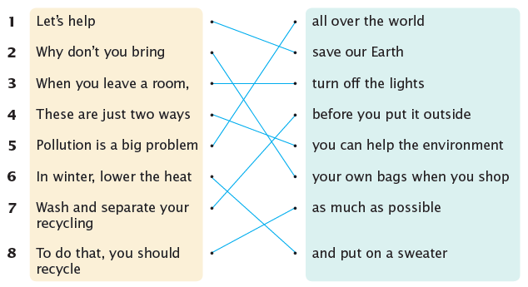

1. Let’s help save our Earth.
2. Why don’t you bring your own bags when you shop?
3. When you leave a room, turn off the lights.
4. These are just two ways you can help the environment.
5. Pollution is a big problem all over the world.
6. In winter, lower the heat and put on a sweater.
7. Wash and separate your recycling before you put it outside.
8. To do that, you should recycle as much as possible.
Unit 7 Join Us at the Fair

A
2. Sports day will be held on the soccer field beside the parking lot.
3. The school play will be held in the auditorium beside the gym.
4. The ice festival will be held at the Spring Resort near Mount Spring.

B
2. Bring your classmates, and you will have a great time!
3. Bring your parents, and you will have an amazing experience!
4. Bring your whole family, and you will have a wonderful evening!

C
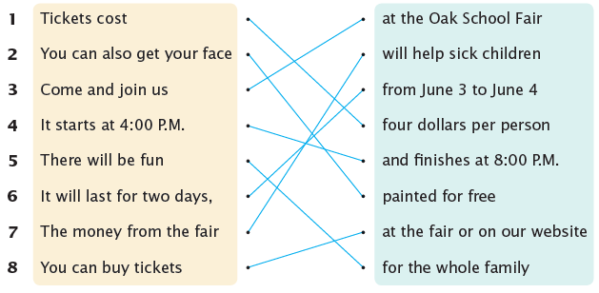

1. Tickets cost four dollars per person.
2. You can also get your face painted for free!
3. Come and join us at the Oak School Fair.
4. It starts at 4:00 P.M. and finishes at 8:00 P.M.
5. There will be fun for the whole family.
6. It will last for two days, from June 3 to June 4.
7. The money from the fair will help sick children.
8. You can buy tickets at the fair or on our website.
Unit 8 My Favorite Painting

A
2. The Scream is famous for its screaming figure.
3. A Stormy Sea is famous for its rolling waves.
4. The Mona Lisa is famous for its mysterious smiling woman.

B
2. I like the Mona Lisa because it looks so peaceful.
3. I like The Scream because it looks so unique.
4. I like The Starry Night because it looks so dreamy.

C
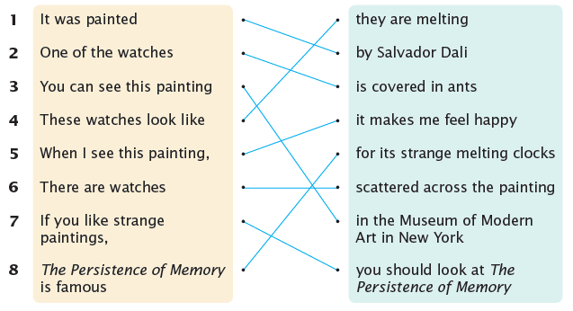

1. It was painted by Salvador Dali.
2. One of the watches is covered in ants.
3. You can see this painting in the Museum of Modern Art in New York.
4. These watches look like they are melting.
5. When I see this painting, it makes me feel happy.
6. There are watches scattered across the painting.
7. If you like strange paintings, you should look at The Persistence of Memory.
8. The Persistence of Memory is famous for its strange melting clocks.

